

**St Philip's Pre-School**

**‘Growing and learning together with kind words, kind hands and a kind heart’**

**Covid Policy**

**Epidemic and Pandemic Policy**

**(COVID 19)**

**Statement of Intent**

St Philip’s Pre-School intend to use this policy to provide precautionary measures to minimize transmission risks of disease in the setting during an epidemic or pandemic.

Legislation and leading authorities which have guided and influenced this policy are:

Coronavirus Act 2020, Health and Safety at Work Act (1974), Health and Safety Executive (HSE), Government Briefings, Public Health England (PHE) and World Health Organization (WHO). Advice from but not limited to, The Secretary of State, The Chief Medical Officer, Local Authority (LA) and Department for Education (DfE). The policy also has regard to Ofsted and Early Years Foundation Stage (EYFS) guidance where appropriate.

**Aim of Policy**

This Policy defines and assists the operating arrangements in place within the setting that assures compliance to the Government and leading bodies requirements with relation to the outbreak of a pandemic such as Covid19. This policy will be reviewed regularly in line with the government guidelines.

As early years providers we ensure to offer a continuum of extremely high standards of practice of childcare and education. The fundamental principles to be outlined in this policy are set out to ensure physical distancing is enabled and implement good hygiene practices as well as avoiding coming into contact with infected children and adults or anyone displaying symptoms. It states the protective measures put in place for children, parents, and staff as best as possible to ensure the risk of transmission is reduced. We will continue to follow our other policies if they do not conflict with this policy.

The main areas we will be considering are:

* Minimising contact with individuals who are unwell
* Maintaining personal and respiratory hygiene (handwashing, catch it, kill it, bin it)
* Ensuring cleanliness of the environment (especially frequently touched surfaces and resources)
* Minimising general contact and mixing (creating bubbles)
* The use of Protective and Personal Equipment (PPE)
* Testing

**Focus/ Areas of Consideration / Recommendations**

**Children**

*Attendance*

* Only children who are symptom free or have completed the required isolation period should attend the setting.
* Staff will be taking temperatures of children on arrival and risk assessing with regular health questionnaires for returning children Physical distancing/ grouping.
* It is the parent / careers responsibility to be open and honest with the setting and keep your child at home if they or anyone in the same household is showing any of the following symptoms: HIGH TEMPRETURE, CONTINUOUS COUGH, LOSS OF TASTE OR SMELL or has had a positive test result or been contacted by track at trace.
* Where possible it is still preferred that children only attend St Philip’s Pre-School. However, we understand that children may need to attend an additional setting/childminder, therefore we ask parents to inform staff immediately of the name and address of the additional setting or childminder in order for us to ensure that the same Covid regulations are being met and adhered to.

*Physical Distancing/grouping*

* Children and staff are no longer operating as separate ‘bubbles’ and now operate as one ‘big bubble’
* We ask that all sunscreen to be applied by the parents / carers before the child arrives at the setting.

*Wellbeing and education*

* Children should be supported in age appropriate ways to understand the steps they can take to keep themselves safe including regular hand washing on entry and continuously throughout the day, coughing/ sneezing into an elbow, using a tissue and adopting a catch it, kill it, bin it regime.
* Children should be supported to understand the changes and challenges they may be encountering because of Covid-19 and staff need to ensure they are aware of children’s attachments and their need for emotional support at this time.
* EYFS framework will continue to be delivered through play and adult led activities.
* Children will have access of fresh drinks of water throughout the day if they are thirsty, staff will monitor this to ensure no cross contamination of beakers.

**Workforce**

*Attendance*

* Staff should only attend preschool if they are symptom free, have completed the required isolation period or achieved a negative test result. All staff and their household are eligible for testing if they display symptoms.
* Temperature of staff will be taken on arrival and risk assessing with regular health questionnaires for returning staff.
* Staff hours, days they work and length of day may change in order to meet childcare demands and considerations within this policy.

*Physical distancing/ grouping /safety*

* Staff to be informed of measures in place and any new or updated policies and procedures.
* Staff have been advised by the government not to wear PPE such as facemasks during their day, but should continue to wear PPE at the usual times such as intimate care and wear disposable gloves and apron if completing one to one care and if supporting an ill child, a face mask and visor should also be worn if a 2-meter distance cannot be maintained.
* After dealing with an ill child who displayed symptoms the staff member should continue to wear PPE and clean the affected area with disinfectant.
* All PPE should be removed and disposed of following current government guidelines, the staff member should wash their hands for at least 20 seconds.
* The staff member who supported the unwell child does not need to go home unless they are developing symptoms themselves.
* Staff may be required to oversee specific rooms or areas including the outdoors to minimise their contact with surfaces etc. This includes potentially working from one table if tabletop toys are available. Staff will be responsible to ensure appropriate cleaning takes place and enough ventilation is in the room such as opening windows. If doors are open, staff will ensure the safety of the children is maintained through continuous risk assessments.
* Staff members should avoid physical contact with each other including handshakes, hugs etc.
* Staff to wear fresh, clean clothes for each session.
* Advise staff to remove their work clothes before the enter their home and take a shower immediately to remove any germs they may have picked up.

*Training*

* Where possible, meetings and training sessions should be conducted through virtual conferencing.
* All staff members must receive appropriate instruction and training in infection control and the standard operating procedure and risk assessments within which they will be operating.
* Online training may be available to allow their training levels to be maintained if appropriate.
* All staff to complete the COVID-19 Training online.

**Parents**

*Physical distancing*

* Only parents who are symptom free and or have completed the required isolation periods will be able to drop off or collect their child.
* Stagger the drop off and collection timings where possible will avoid a queue of families waiting to enter nursery.
* Arrange drop off and pick up at preschool entrance’s to avoid parents entering the setting unnecessarily.
* When parents are waiting to drop off or collect their child, physical distancing should be maintained in a safe area sticking to government social distancing policies.
* The provider should consider measures to minimise contact between the parent and other children and staff members.
* Parents will not be allowed the setting; they must stay 2 meters away from staff

*Communications*

* Parents should receive clear communication regarding the role they play in the safe operating procedure and all measures being taken to ensure the safety of their children and themselves.
* Parents should inform the setting of their circumstances and if they plan to keep their child away.
* Although handovers are kept to minimum, we encourage parents and staff to have continuous communication via phone calls throughout the day.
* Any parent meetings can be arranged via zoom at a convenient time for both the key person and parent/ guardian.

**Visitors**

* Attendance to the setting is still restricted to only children and staff as far as practically possible and visitors should not be permitted to the setting unless essential (e.g. essential building maintenance). However, certain professionals will be admitted in order to support the learning and development of the children.
* Where essential visits are required, these should be made outside of the usual setting operational hours where possible, if this is not possible the area will be cleared of children, staff and the visitor will be asked to wear appropriate PPE. Any Visitors MUST sign a COVID-19 disclaimer and have their temperature taken upon arrival. Any Visitor that refuses to comply will be denied access to the setting.
* Parents and carers should not enter the premises, unless necessary in an emergency.

**Travel**

* If public transport is necessary, current guidance on the use of public transport must be followed.
* Outings from the setting will still continue to local parks and outside walks but will be restricted in more confined areas to ensure mixing with members of the public does not happen.
* Staff to Provide a change of clothes before they start their shift if traveling to work Via public transport.
* If children travel on public transport or taxis, parents will be responsible for removing their outer clothing which will not enter the premises.

**Hygiene and Health & Safety**

*Hand Washing*

* All children and staff must wash their hands upon arrival at Pre-School for at least 20 seconds.
* Children and staff members should be encouraged to wash their hands frequently, this includes before and after eating food, after visiting the toilet or playing outdoors, after sneezing, blowing their nose or coughing into their hand and dealing with unwell individuals.
* Bodily fluid spills should follow the correct procedures as normal.

*Cleaning*

* + An enhanced cleaning schedule must be implemented that includes furniture, surfaces and children’s toys and equipment and all staff are responsible in their area of work.
  + Communal area, touch points and hand washing facilities must be cleaned and sanitised regularly and cleaned thoroughly every night.
  + A deep clean may be needed after a child has become ill in the area they were waiting.
  + Staff will complete a vigorous deep clean once all the children have left the setting.
* Staff will use the disinfectant fogger daily, to disinfect each room to ensure walls floors and all other surfaces are completely germ free.

*Waste disposal*

* All waste must be disposed of in a hygienic and safe manner following government guidelines.
* Tissues must be immediately disposed of and placed in a bin with a bag.
* Bodily fluids must be double bagged and disposed of in a bin with a bag, lid, and foot pedal.

*Risk assessment*

* The setting and all activity should be risk assessed before opening or going ahead to address the risks from the virus and due consideration given to any adaptations to usual practice. Sensible measures should be put in place and policies and procedures followed.
* It is expected that would include, but not be limited, to the suspension of learning experiences involving materials which are not easily washable such as malleable materials (dough, clay) and the suspension of the sharing of food and utensils.
* Cut down on the available resources out in the setting.
* Remove anything which cannot be easily wiped down or washed at the end of the day.
* Play food, play cutlery and crockery etc, should be removed or anything else which may be ‘mouthed’ by many children.
* Baking, food play and finger painting should be avoided.

*PPE*

* Government guidance is that PPE is not required for general use in early years settings to protect against COVID- 19 transmission.
* PPE should continue to be worn and disposed of as normal for nappy changing, one to one care and the administration of first aid.
* If a child shows symptoms, staff should wear a face mask, visor, disposable gloves, and apron if a 2-meter distance cannot always be maintained. PPE should be disposed of following government guidelines

*Premises Building*

* Keep windows open where possible to ensure good levels of ventilation. If doors are opened ensure the children safety is maintained with locked gates.

*Resources*

* Children should not be permitted to bring items from home into the setting unless essential for their wellbeing. Anything that is brought in from home should remain in the child’s bag on their peg.
* All resources required for play and learning experiences of children should be regularly washed and/or sterilized. Any resources which are difficult to clean should be removed.
* Equipment used by staff such as stationary, tablets etc, should be allocated to individual staff members where possible and cleaned regularly.

*Supplies Procurement & monitoring*

* The setting should ensure an adequate supply of essential supplies and contingency plans such as additional suppliers are in place to minimise the impact of any shortages of supplies.
* The setting will not be able to operate without essential supplies required for ensuring infection control.
* A monitoring system for the usage of PPE is essential to ensure that a supply of stock is available to all who require it as and when required to meet the operational needs of the setting. When stocks are low, other options may be considered, such as the use of washable tabards and facemasks. These items will be washed at a high temperature in accordance with relevant guidelines and separate to any other washing.

*Responding to a suspected case*

* In the event of a child developing suspected coronavirus symptoms whilst attending the setting, they should be collected as soon as possible and isolate at home in line with the current NHS guidance.
* Whilst waiting for the child to be collected they should be isolated from others in a previously identified room or area. If possible, a window should be opened for ventilation.
* The staff member responsible for the child during this time should be a staff member from their ‘bubble’. The provider may consider suitable PPE for this staff member such as the addition of face mask, visor disposable gloves and apron.
* The area should be thoroughly cleaned, immediately.
* The person responsible for cleaning ideally should be the person dealing with the unwell child and should continue to wear their PPE. This should then be disposed of according to current government guidelines.
* In the event of a staff member developing suspected coronavirus symptoms whilst working at Pre-School, they should return home immediately and isolate at home in line with the NHS guidance. They should also follow current testing advice for themselves and their household.

*In the event of a positive case, outbreak, or closure.*

* Parents/ carers are responsible to notify a member of the management team at the earliest point of receiving a positive test result.
* If a “bubble” has been exposed a member of the management team will then notify all families within that ‘bubble’ as early as possible to notify of closures or to arrange immediate collection of their child.
* Additional cleaning will be arranged for that ‘bubble’ to ensure minimal spread of the virus.
* Staff will continue to contact the parents and families via telephone to answer any questions and offer support.
* The manager will notify Ofsted, environmental health, and the local authority as well as gain advice from the Gateshead coronavirus cell and DFE (department for education).

*Procedure*

The child will have to isolate for 10 days of symptoms developing and anyone that lives within the same household will have to isolate for 10 days unless tested and has a Negative test result. Isolation **MUST** continue until results are back.

In the case of a **POSITIVE** result within the setting please see table below for isolation periods.

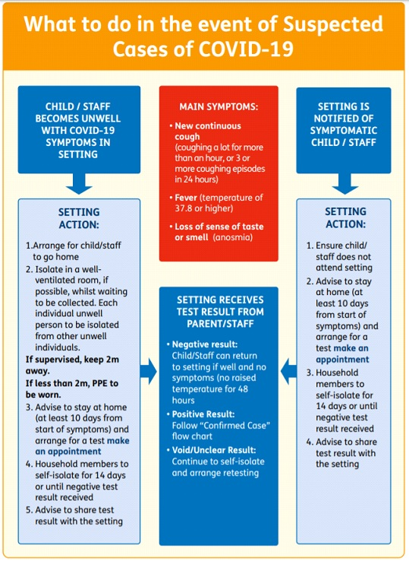

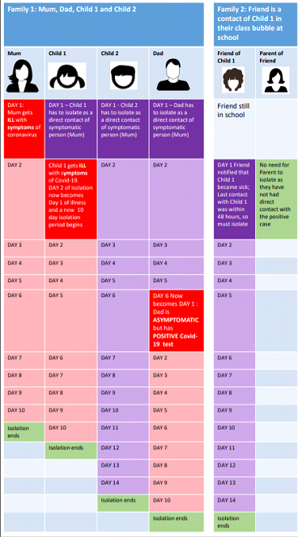

Any parent / career failing to inform the setting of anyone living in the household with symptoms, a positive result or being exposed to COVID-19 and has been advised to isolate from track and trace but continues to attend will risk immediate termination of their contract with St Philip’s Pre-School for putting other children, staff and families at risk.